User Testing: hangman.py

This document provides comprehensive testing for the hangman.py script. Test data includes all possible inputs, whether valid or invalid.

# Login

When hangman.py is run, the user is prompted to enter a username. Characters allowed are uppercase and lowercase letters, '-' and '/'. Invalid inputs will cause the program to keep prompting until a valid username is entered.



Invalid username inputs:

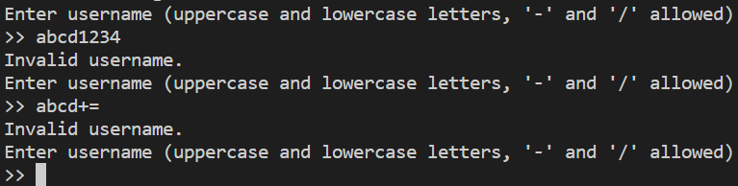

Valid username input:

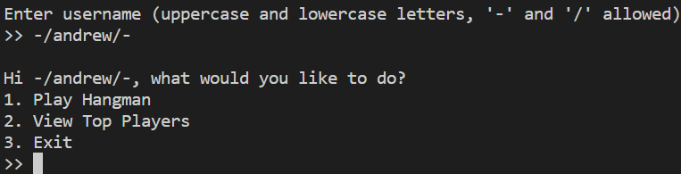

# Main menu

The main menu displays 2 main options and 1 exit option and prompts for an input. Invalid inputs will cause the program to keep prompting until a valid input is entered.

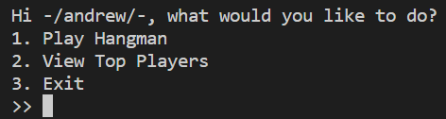

Invalid input:

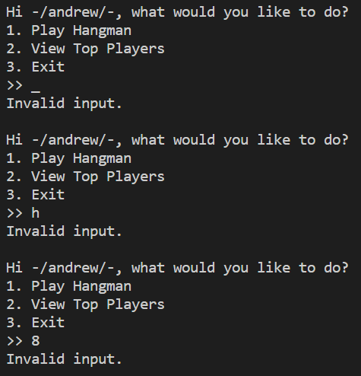

Valid input:

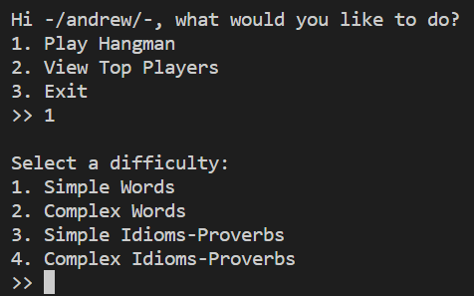

# 1. Play Hangman

Option 1 of the main menu will first prompt a user to select a word pool from 4 options. Invalid inputs will cause the program to keep prompting until a valid input is entered.

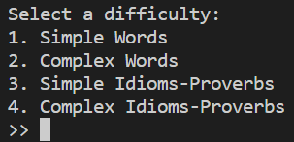

Invalid input:

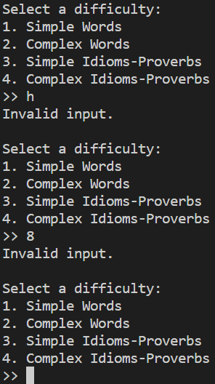

Valid input:

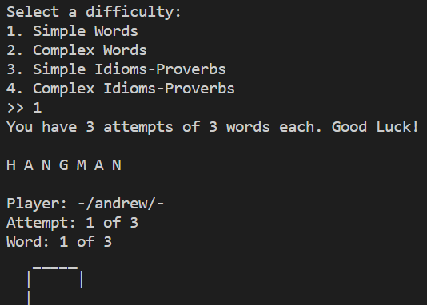

# Play Hangman > Guessing a word

Here, the hangman game has started. The user is to guess letters until the whole word is guessed or the maximum number of guesses is reached. This goes on for as many words x attempts that have been specified in the settings.

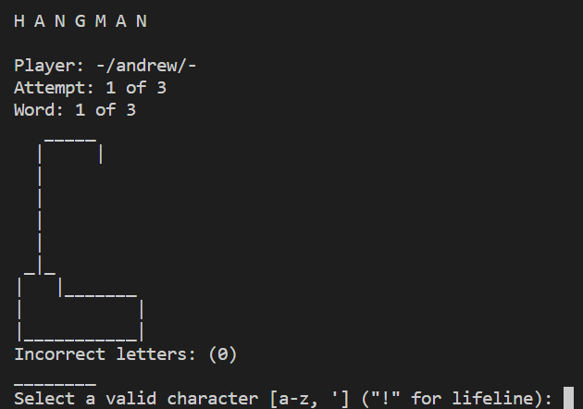

Invalid input:

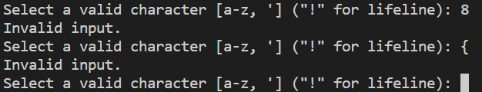

Valid input:

Correct letter:

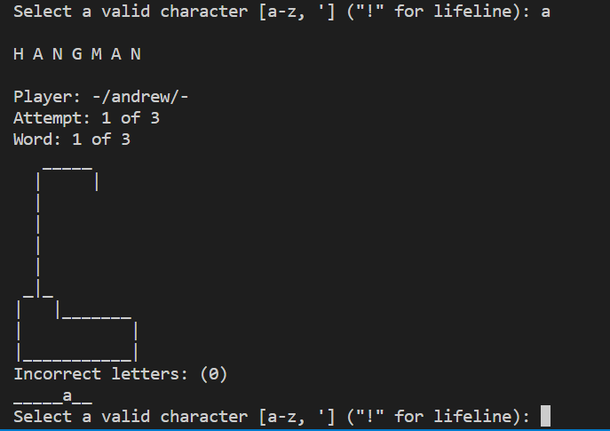

Incorrect letter:

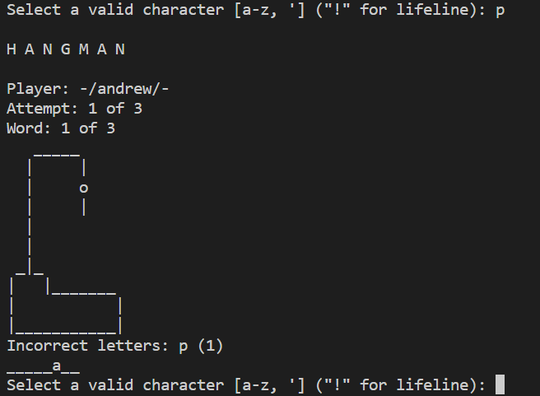

Lifeline:

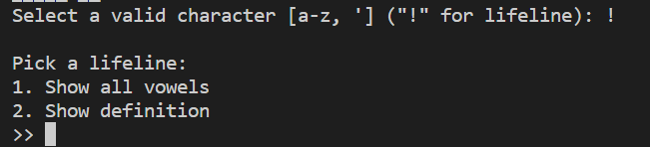

If lifeline has been used this word or 2 lifelines have been used this attempt:



Word not guessed but maximum number of guesses reached:

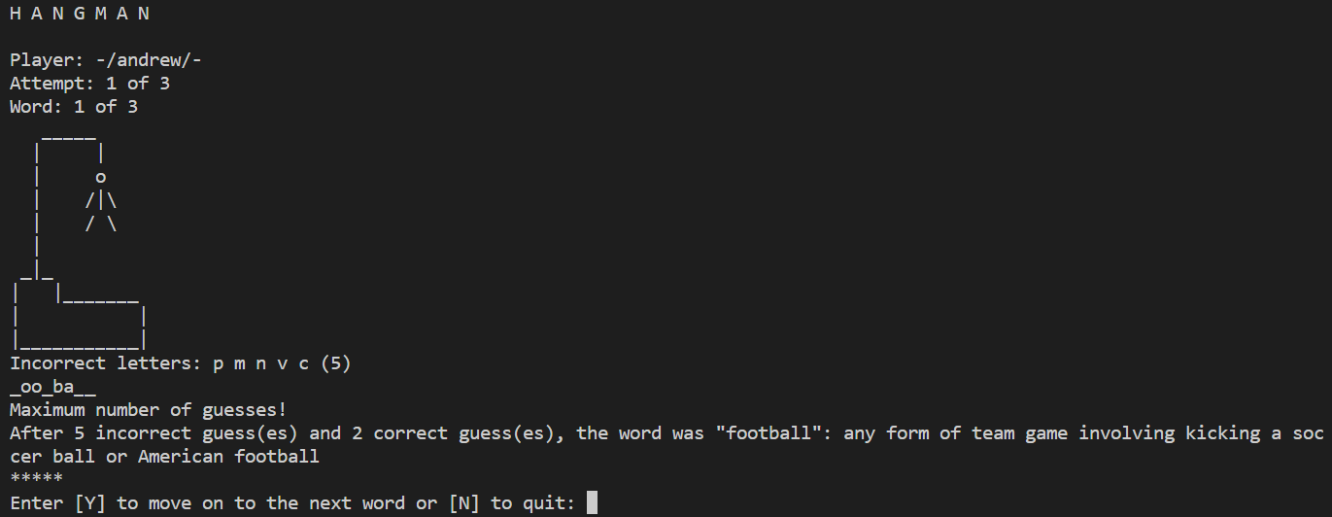

Word guessed successfully:

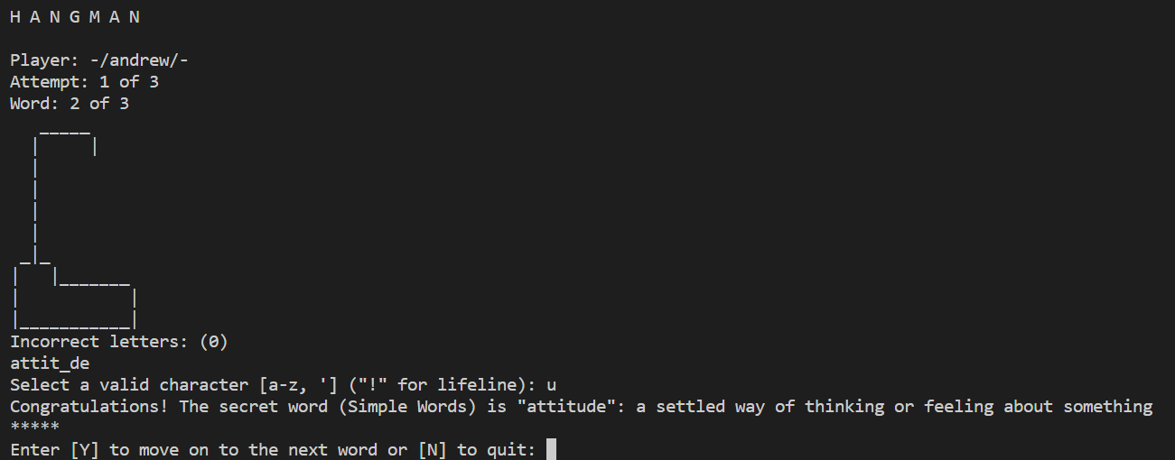

# Play Hangman > Finishing a word

After each word, user is prompted to enter whether to continue to next word or not. Invalid inputs will cause the program to keep prompting until a valid input is entered.

Invalid input:

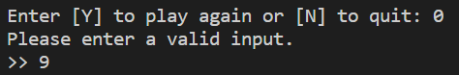

Valid input:

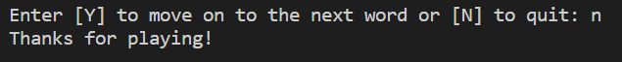

# Play Hangman > Finishing an attempt

After each attempt, user is prompted to enter whether to continue to next attempt or not. Invalid inputs will cause the program to keep prompting until a valid input is entered.

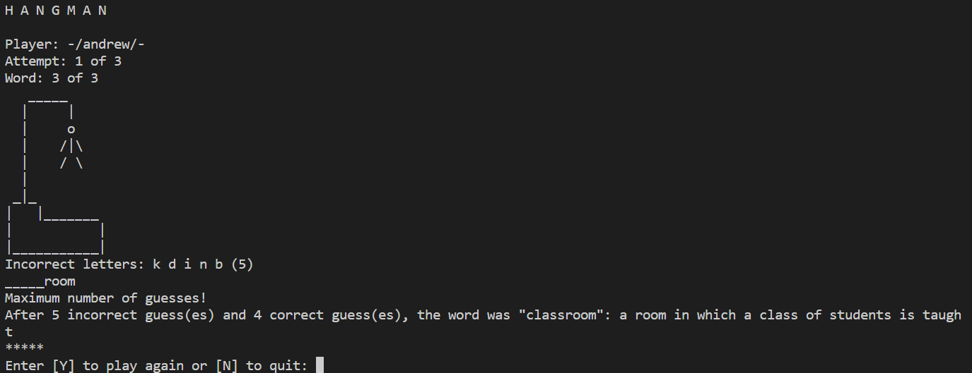

Invalid input:



Valid input:

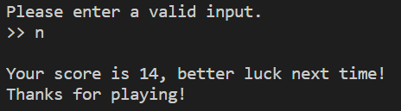

# Play Hangman > Finishing a game set

If the player attained >15 points across all attempts, they have won

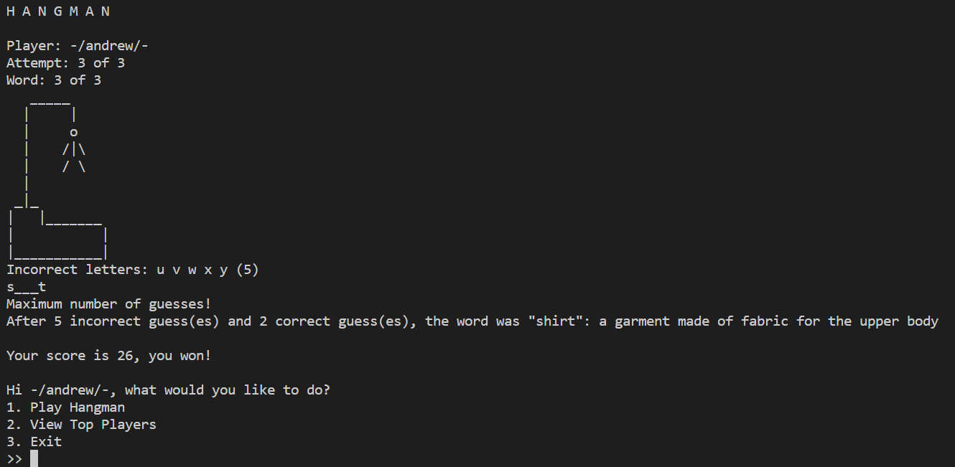

If the player attained <15 points across all attempts, they have lost

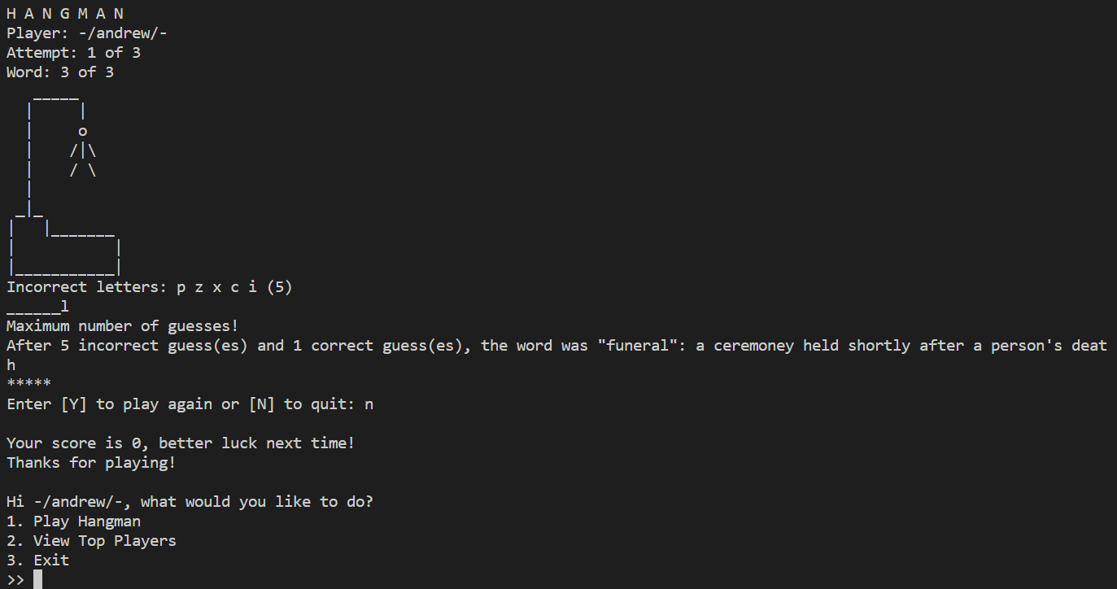

# Play Hangman > Lifelines

Invalid lifeline input:

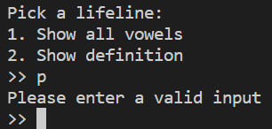

Valid lifeline input:

1. Show vowels:

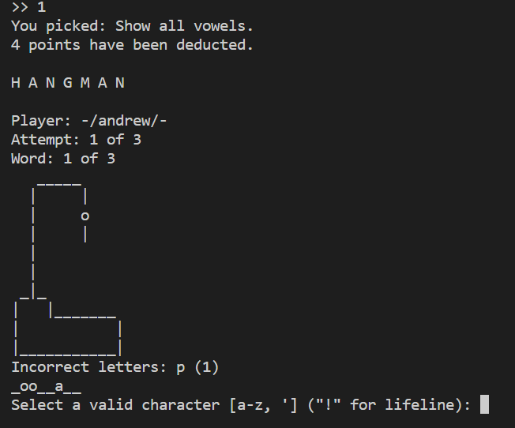

1. Show Definition:

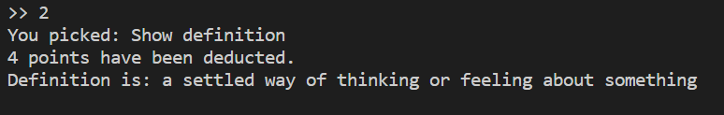

# 2. View top players

Option 2 of the main menu display the top players based on the number of top players specified in the game settings.

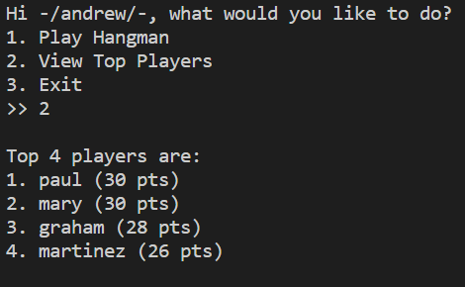

# 3. Exit

Option 3 of the main menu exits the program

